SPH3U0 Wave Properties in One-Dimension Name:___________________

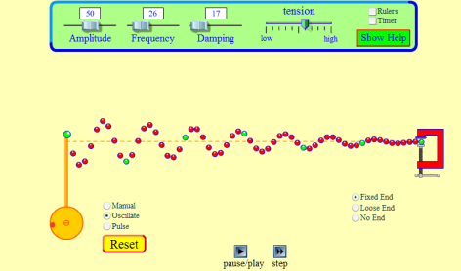***Learning Goal****:* to investigate the behaviour of waves in a one-dimensional medium (e.g. string, spring, etc.)

***Key Terms***: amplitude, wavelength, frequency, phase, attenuation,

reflection, fixed end, free end

**Instructions:** Go to <http://phet.colorado.edu/en/simulation/wave-on-a-string>

**Wave Speed and Attenuation:**

1. Set the tension to the HIGH and the damping to 0. Wiggle the wrench up and down ONCE to produce a single pulse ( ) that travels down the rope.

a) Describe the speed of the wave.

b) Set the tension to the MIDDLE and wiggle the wrench again. How does tension affect wave speed?

2. a) Reset the TENSION to HIGH and set the DAMPING to ONE QUARTER. Wriggle the wrench again. Describe what happens to the amplitude of the pulse.

b) The damping represents frictional forces in the material. Explain what is happening to the energy of the wave as it travels through a “real” material where frictional forces are present.

**Refection at Fixed and Free Ends:**

3.a) Set the damping to 0 and the tension at the MIDDLE level and produce a large amplitude, single “up”   
pulse (e.g ) which travels towards the fixed end. How does the reflected (outgoing) pulse compare to the incident ( incoming) pulse? Sketch the result.

b) Change the end to a “loose” end and repeat the experiment. How does the reflected wave compare to the incident wave in this case? Sketch the result.

**Frequency and Wavelength**

a) Switch from the manual wrench to **OSCILLATE**. **LEAVE THE TENSION ON HIGH. Set the AMPLITUDE AT 0.70, FREQUENCY AT 1.30 AND THE DAMPING AT 0**. Hit restart. After a few moments, stop the simulation and sketch the waveform.

b) Switch the frequency to 1.80 and hit restart. After a few moments, stop the simulation and sketch the waveform.

c) What do your results indicate about the frequency and wavelength of a wave travelling in a given material?